Elliott Waves Pattern

[The Secret Mindset](https://www.youtube.com/channel/UC9yk_6ks1g1ipJJsxtLKLcA)

[Video’s source](https://www.youtube.com/watch?v=tMjgiULV_5k)

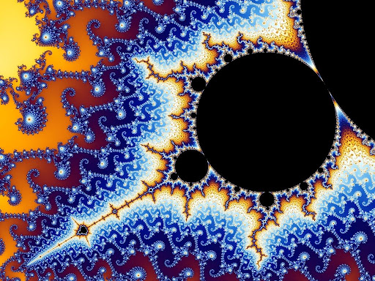

Figure : Fractal pattern, [source](https://www.google.com/url?sa=i&url=http%3A%2F%2Fwww.futura-sciences.us%2Fdico%2Fd%2Fmathematics-fractal-50000443%2F&psig=AOvVaw0sT1IQ1Hd0hWsBH4cItJ5-&ust=1640437883966000&source=images&cd=vfe&ved=0CAsQjRxqFwoTCMiXisPB_PQCFQAAAAAdAAAAABAE).

This document is intending to make a writing summary of The Secret Mindset’s video about the Elliott waves pattern.

Table of content

1. Introduction 3

2. Motive Waves structure 4

a. Wave 1: 4

b. Wave 2: 4

c. Wave 3: 4

d. Wave 4: 4

e. Wave 5: 5

3. Corrective structure 6

a. Wave A 6

b. Wave B 6

c. Wave C 6

4. Elliott waves checklist 7

5. Examples 8

Table of figures

Figure 1: Fractal pattern, source. 1

Figure 2: Elliott waves pattern 3

Figure 3: 3 unbreakable rules designed to distingue impulse wave 3

Figure 4: Wave 1 4

Figure 5: Wave 2 4

Figure 6: Wave 3 4

Figure 7: Wave 4 4

Figure 8: Wave 5 5

Figure 9: Wave A 6

Figure 10: Wave B 6

Figure 11: Wave C 6

# Introduction

* **Fractal nature of markets**: price patterns repeat themselves over and over again on all time frames.

2 types of price progressions:

* 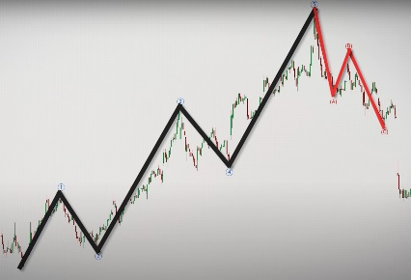**Motives waves**:

Figure : Elliott waves pattern

* + Price movements that are aligned with the larger trend.
  + Classified as **impulse**.
  + Typically divided into **5 sub-waves: 1, 2, 3, 4 and 5.**
* **Corrective waves:** 
  + Price movements that are contrary to the larger trend.
  + Typically divided into **3 sub-waves: A, B, C.**

They are **3 unbreakable rules (UR)**: if one of these rules is violated, the structure is not an impulsive wave:

* **Wave 2** cannot retrace more than 100% of wave 1
* **Wave 4** cannot move into the territory of wave 1
* **Wave 3** cannot be the shortest among waves 1,3 and 5

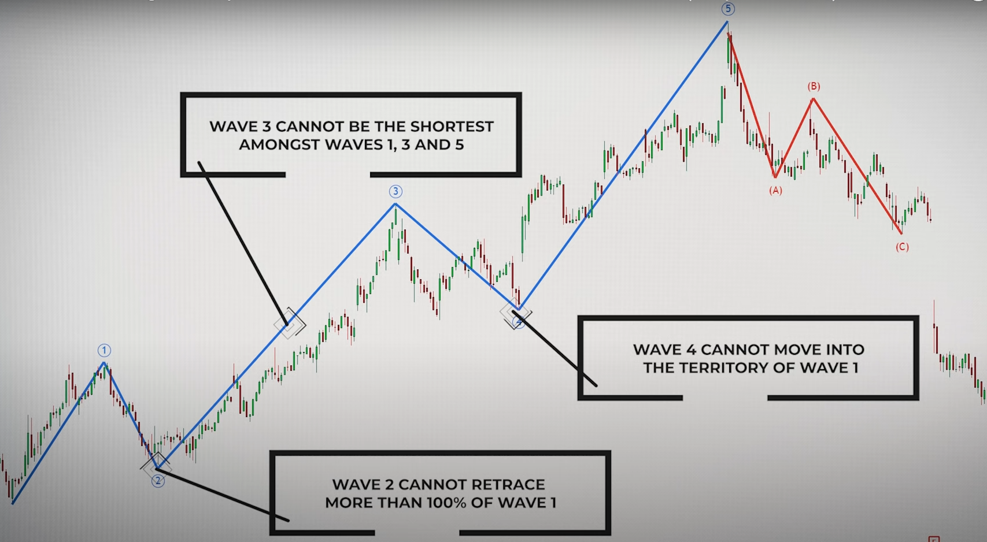

Figure : 3 unbreakable rules designed to distingue impulse wave

# Motive Waves structure

Often a **5 sub-waves** pattern.

## Wave 1:

Figure : Wave 1

* Prices begin to bounce higher after a long-sustained downtrend.
* The sentiment in the market is still bearish at the start of this wave.
* The **least predictive wave** within the entire Elliott wave structure.
* No way to know how long this wave will last.
* A new **swing high is reached**.
* **Projection**: Uncertain.

## Wave 2:

Figure 5: Wave 2

* People feel assured once again that downtrend has continued
* Usually an **ABC pattern**.
* **Reminder UR**: cannot retrace more than 100% of wave 1.
* **Projection:** **retrace a large portion of wave 1**: either 50%, 61% or even 78%

## Wave 3:

* **Biggest** and most **powerful** wave
* The sentiment in the market is bullish
* After the wave 1 swing high break, price will begin to accelerate upward as people recognize the bullish sentiment.

Figure 6: Wave 3

* **Recognize it quickly as possible** in order to take advantage of the explosive moves.
* Wave 3 offers very little retracement or they tend to be quite shallow.
* **Projection** from the end of wave 2:
  + 1st: often travels 1.618 times the length of wave 1
  + 2nd: most common projection is 2.618 times the length of wave 1.

## Wave 4:

Figure : Wave 4

* Shallower retracement.
* **Less aggressive** than wave 2.
* Often see as profit-taking wave: traders that bought early in wave 3 begin to liquidate their positions.
* Often appears range bound and generates false breakout in either side of the market.
* **Be careful** when taking new positions during this wave.
* **Reminder UR**: should not overlap into the territory of wave 1.
* **Projection:** Often terminate at 38% or 50% of wave 3.

## Wave 5:

Figure : Wave 5

* During the progression almost everyone is bullish.
* Traders drive price higher, often to extreme valuations.
* **Momentum divergences**: the **velocity** of the price movement higher is **diminishing** and you should expect the **upside trend to reverse** its course soon.
* Often register **lower volume** compared to wave 3.
* **Projection** from the end of wave 4**:** 
  + 1st: length that is equivalent to wave 1.
  + 2nd: 61% of the length of wave 1

# Corrective structure

Often a **3 sub-waves** pattern.

## Wave A

Figure : Wave A

* Sentiment still very bullish, and consider that wave pullback as just another minor retracement.
* It is **similar** to the structure of **wave 1**.
* Wave A is often a **sharp move** and may subdivide as either a five-way pattern or a three-wave pattern.

## Wave B

Figure : Wave B

* Often considered as a **bull trap**, because it tends to create the belief that the existing trend is still healthy.
* Try to test the wave 5 extreme, and in most cases will fail to breach it.
* Is often a deep retracement.
* It (might be) consider as a sell area.
* **Projection**: Either retrace wave A by either 50%, 61% or 78%.

## Wave C

Figure : Wave C

* Break the swing low of wave A.
* **Sentiment** will become convinced that the **uptrend has actually ended**.
* It is **similar to the wave 3 structure**: tend to be **relatively long** and can be **quite powerful** from the momentum standpoint.
* **Projection**:
  + 1st: 1.27 times the length of wave A.
  + 2nd: 1.61 times the length of wave A.

# Elliott waves checklist

Use to confirm the Elliott wave pattern

* Wave **1, 3 and 5 are trending.**
* Wave **2 and 4 are corrections.**
* Of wave 1, 3 and 5, the **3rd must not be the shortest**, but it does not have to be the longest.
* Wave **2 can retrace up to 99%** of wave 1.
* Wave **4 should not go into the price area of wave 2**.
* Wave **2 and 4 must display alternation** as many ways as possible (must be different):
  + **Price**: wave 2 compared to wave 4 may be obviously smaller/larger.
  + **Time**: take much more/less time.
  + **Pattern**: wave 2 may be a simple ABC and wave 4 could be more complex.

# Examples

Train to recognize Elliott waves pattern

